

USER GUIDE

FOR

PATIENT DATA EXCHANGE SERVER



**Login into Patient Data Exchange Server**

To Login into Patient Data Exchange Server you should have a valid account and password. You cannot access the Patient Data Exchange server until you have a valid account and Password.

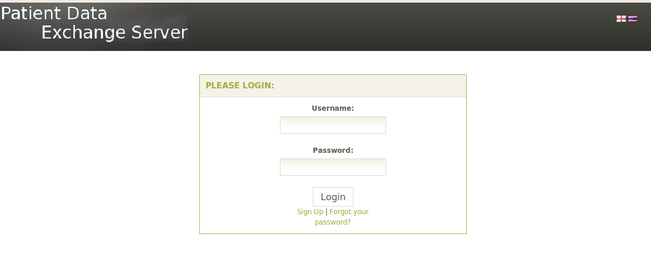

Enter the valid username and password click a login button then you will be taken into a Homepage of particular user. If you enter invalid username and password then will get a message that incorrect username and password is enter

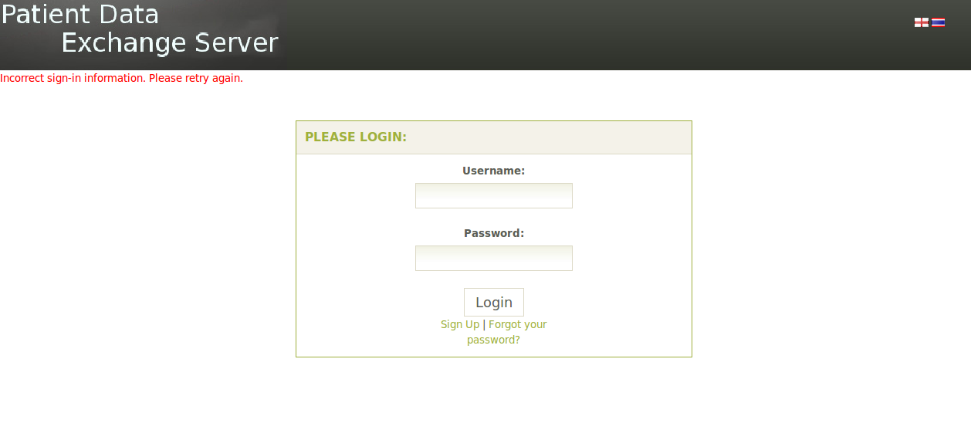

If you receive the above page then, enter the username and password again, click the login button, if you continue to have problems while logging then contact system administrator or you may have a option to recover a password if you forgot your password.

**Password Recovery**

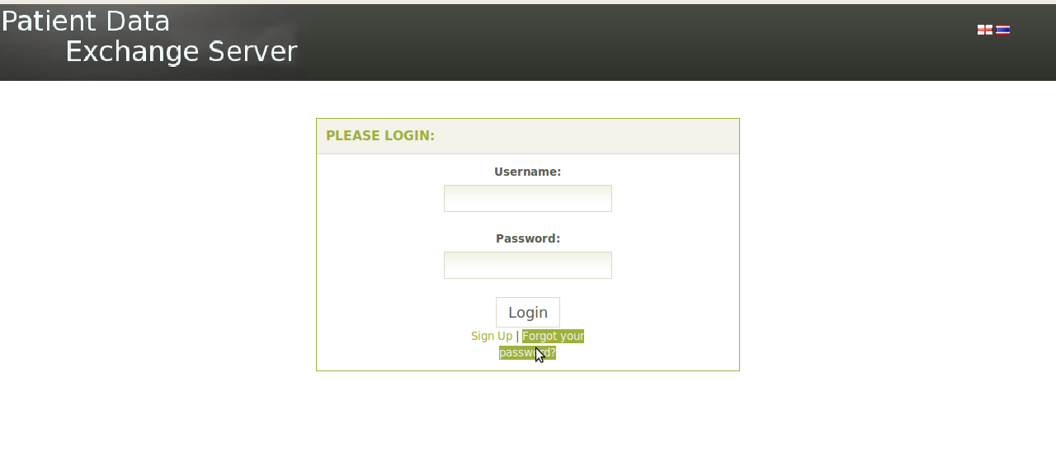

If you forgot the Password, Click on Forgot your password Button then you will be redirected to the password recovery page.

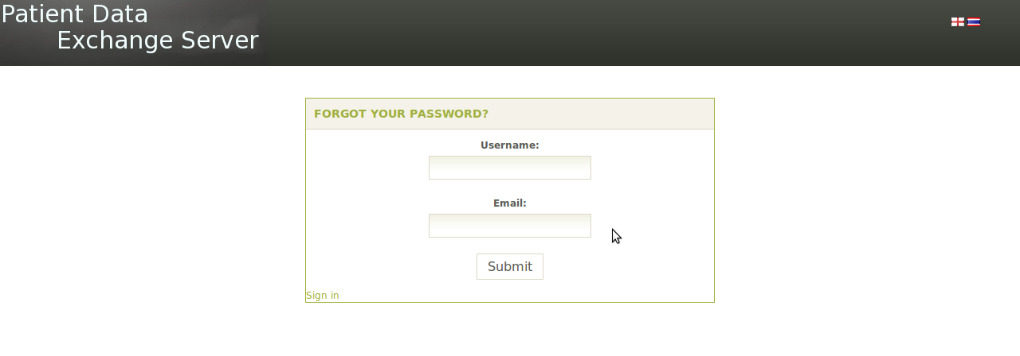

Enter the valid username and Email address to get the new password. The password will be send to you in your mail address.

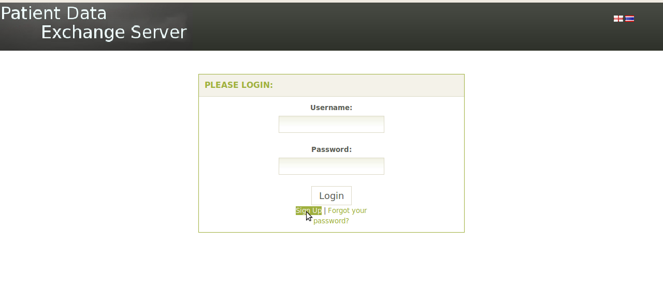

**Registration**

If you do not have an account of the Patient Data Exchange Server then Click the Sign Up button. Then you will redirected to the page that will ask you to fill up the form, fill up the form and click the submit button.

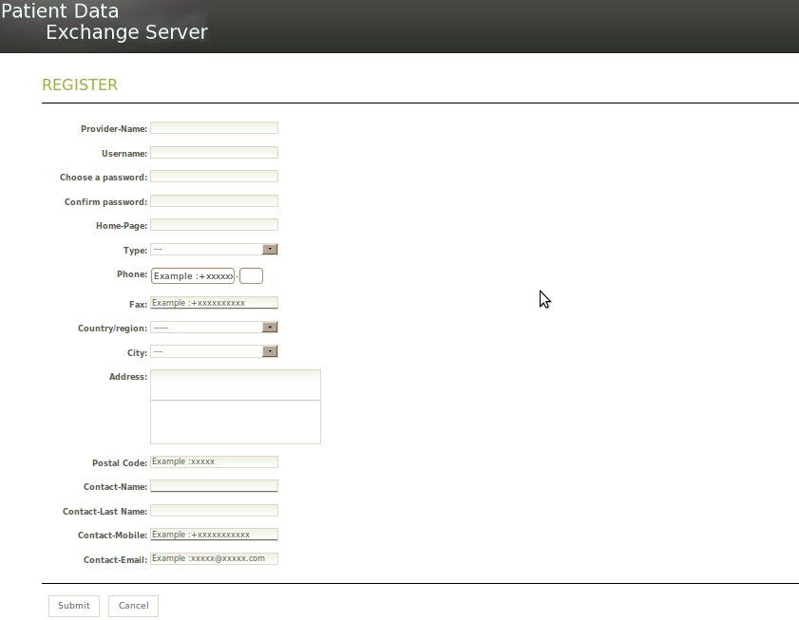

Once you submit the form, you will get email for activation of your account, you will not get activation email until the administrator will verify and activate the account.

**Administrator Login**

To Login into Administrator of Patient Data Exchange Server you should have a valid account and password. You cannot access the Patient Data Exchange server administrator account until you have a valid account and Password.

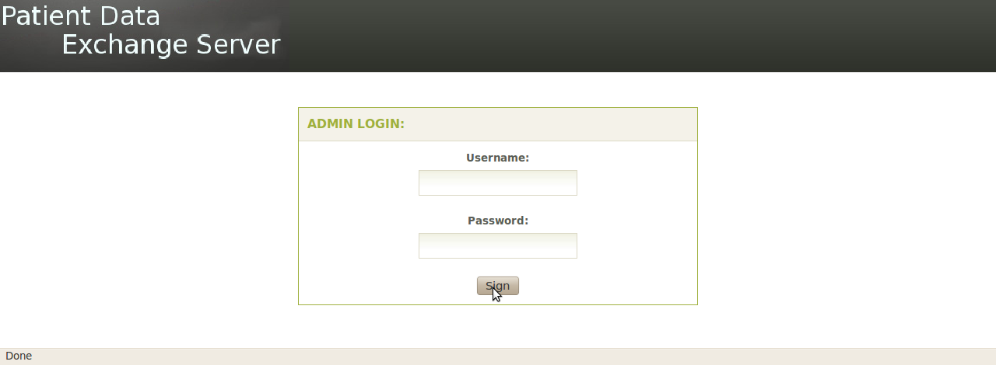

Once you login with valid username and password of admin you will be directed to the homepage of admin.

**Homepage of Admin**

The Homepage of Admin shows immediately after logging into the Admin account application.

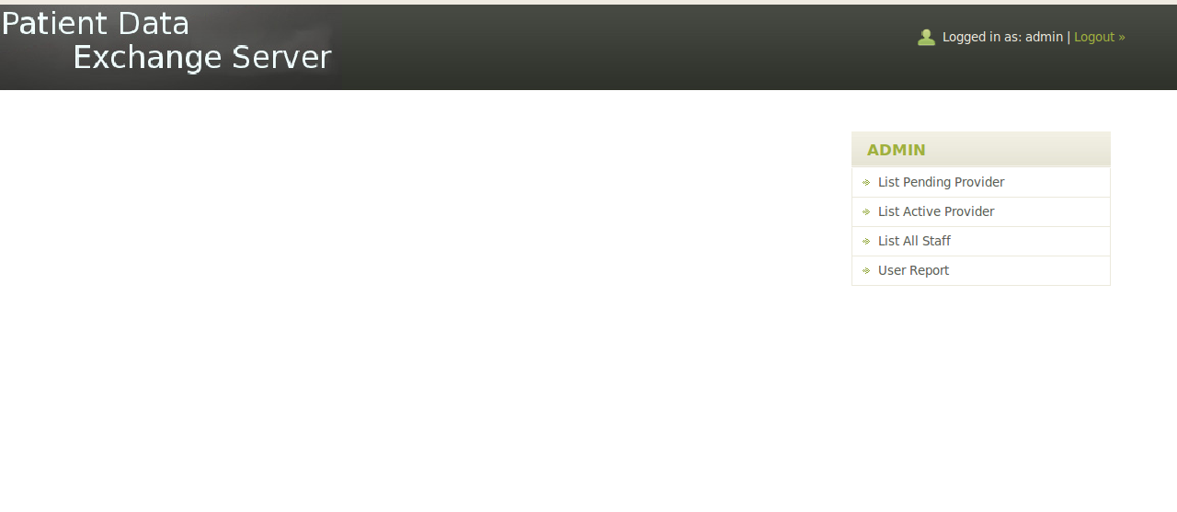

**Navigating the Admin Homepage**

Various functions of admin can be accomplished by navigating the frame on the right side of browsers.

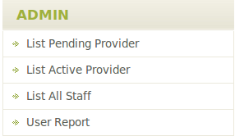

List Pending Provider: Display the registered users that are not activated.

List Active Provider: Display the registered users that are activated.

List All Staff: Display the Personal that associated each user.

User Report: Display the Login Information of Users at what time it was Online and Offline.

**List Pending Providers**

It display the registered user that are not activated, administrator will verify and activate the user account by sending a mail to the user. Once the user gets the mail then user can activate the account.

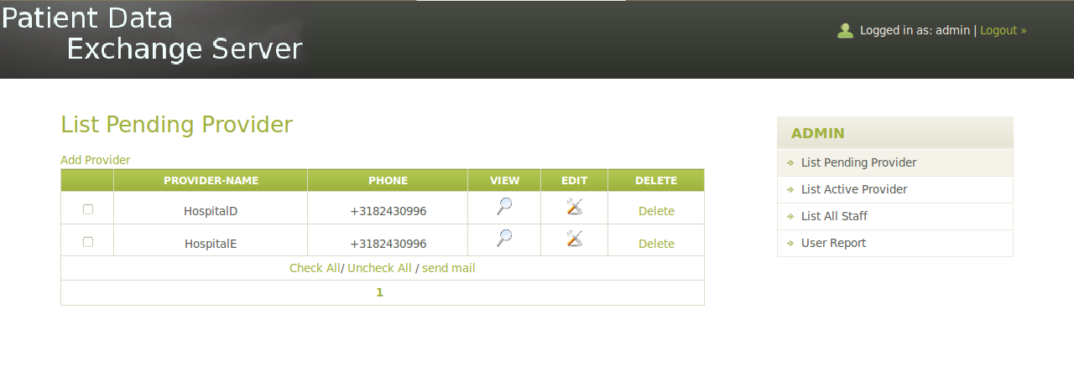

**List Active Providers**

It displays the activated registered user. Administrator can view,edit the information of each user. Administrator can also lock/unlock the user account

Temporarily or delete the account permanently.

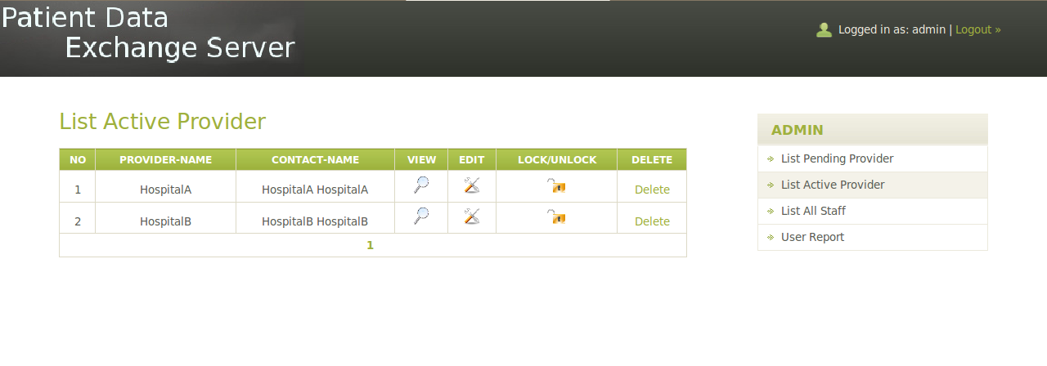

**List Staff**

It displays the Staff related to each registered user.

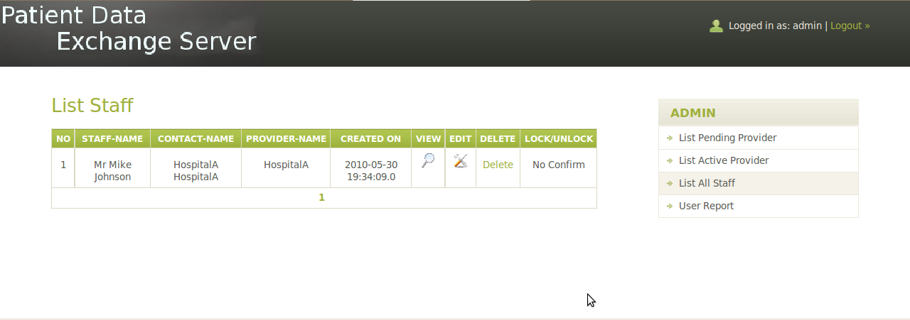

**User Report**

It displays the information about the user at what time the users were online and offline. We can also download the user report by clicking the download button.

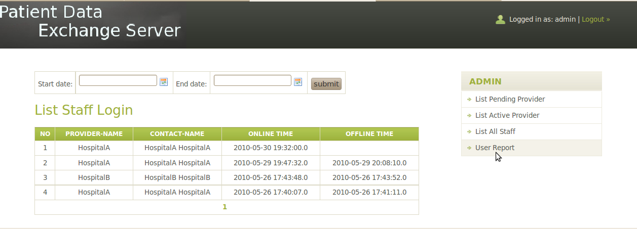

**Home Page of User**

The Homepage of User shows immediately after logging into the Patient Data Exchange Server User account application.

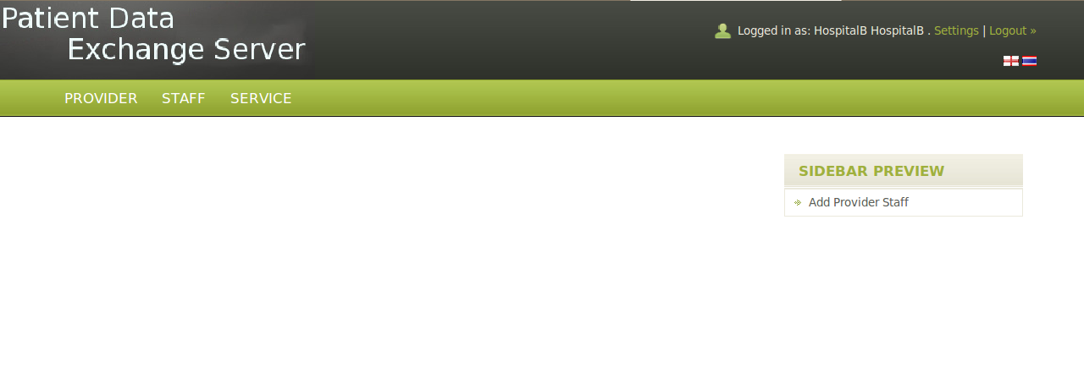

Various functions of users can be accomplished by navigating the frame on the top right side of browsers.

**Provider**

When you click the Provider Tab you will see three more option view, edit, Change password. The View option will display the user’s information, edit option will allow you to change or update the information regarding users and change password option will allow you to change the password of the users.

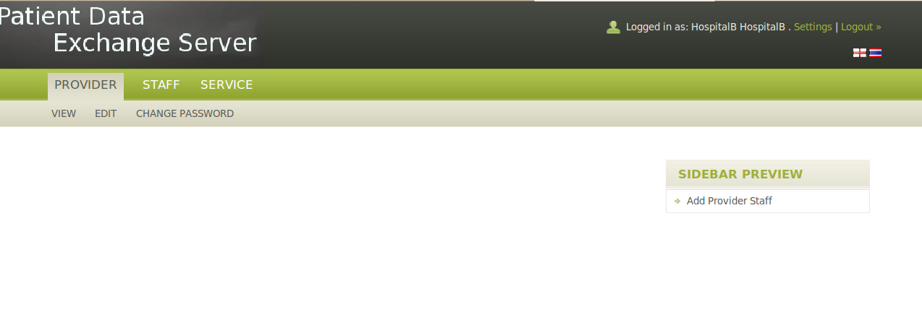

**Staff**

When you click the Personal Tab You will see two options Add Personal and List Personal. Add Personal will add a new personal to the user and list personal will list the all personal that is associated with given users.

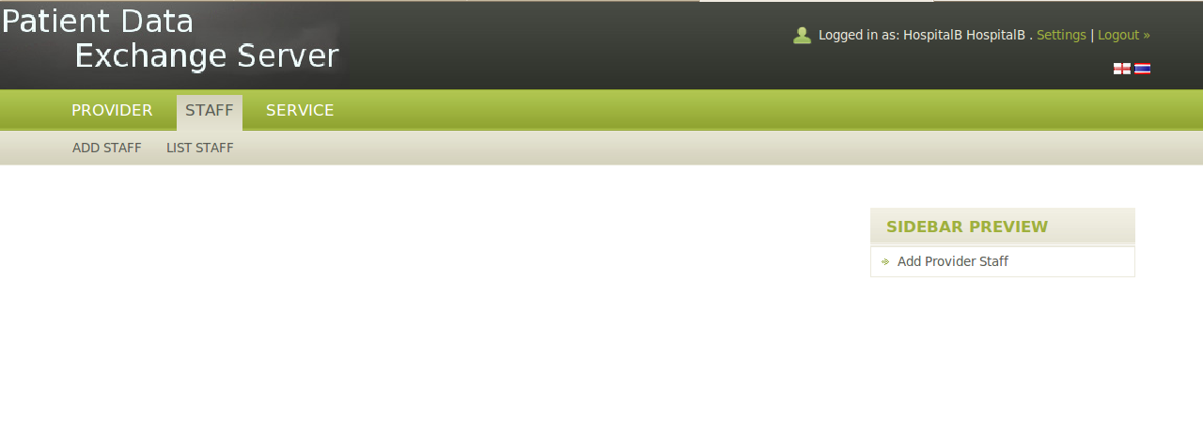

**Service**

When you will click the service tab you will see the four options List Provider, List Provider Connect, Sent Provider Request, and Provider Request.

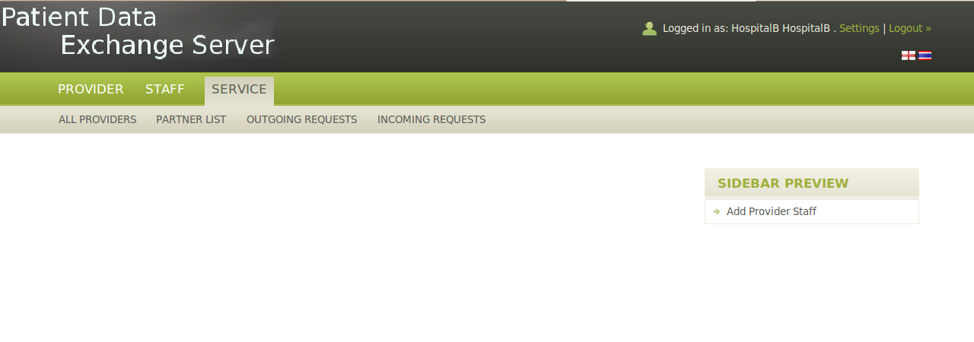

**All Providers**

List Provider will list all the number of Hospital that is registered to Patient Data Exchange Server and that provide a service to exchange a patient data between them.

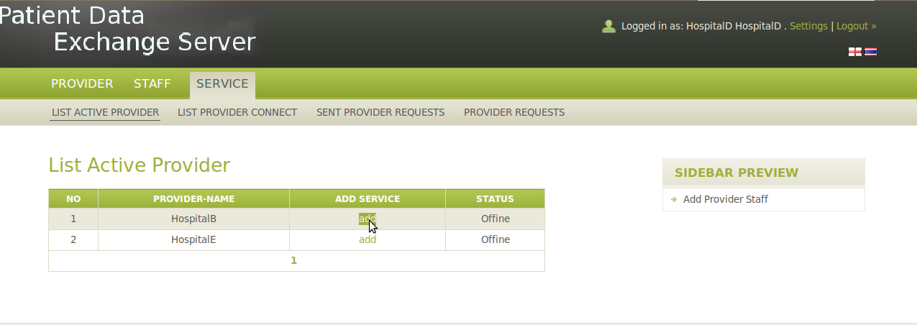

When you will click the add button to add a service to exchange a Patient data between two provider, request is send to respective provider.

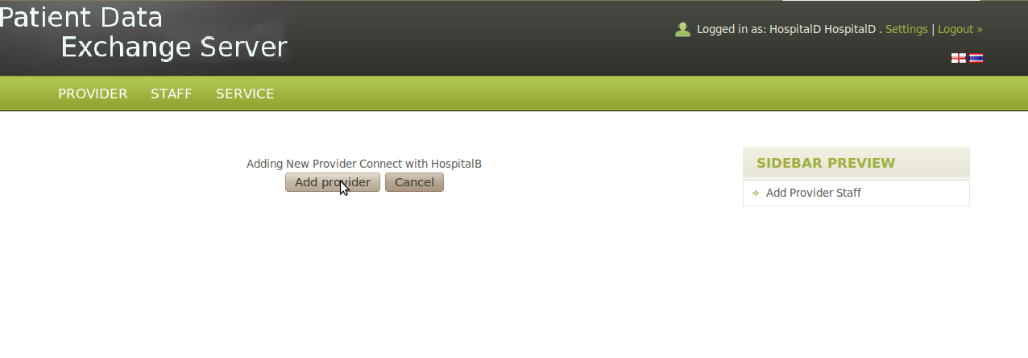

**Outgoing Requests**

When you will click the Outgoing Requests tab it will display the requests that you have send to different provider and there status whether it has been accepted or waiting.

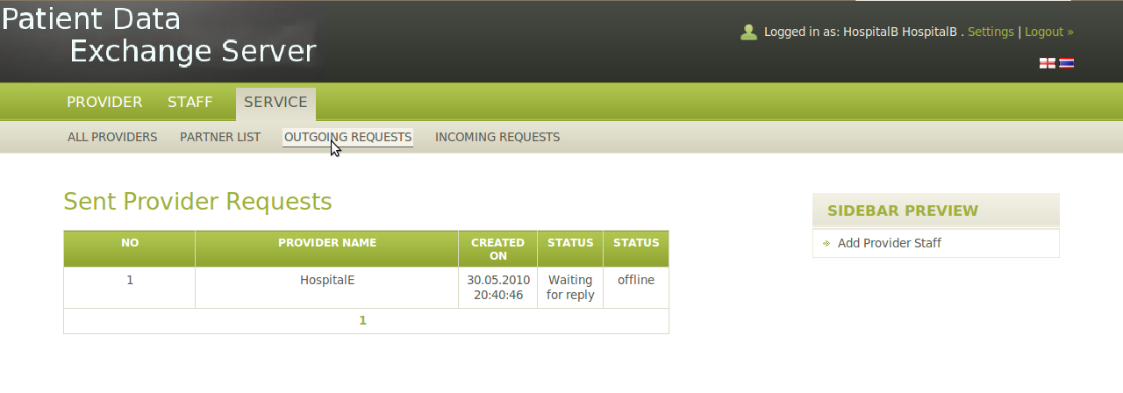

**Incoming Requests**

When you will click the Incoming Requests tab it will display the requests that you have recieve from different provider and there status whether it has been accepted or waiting.

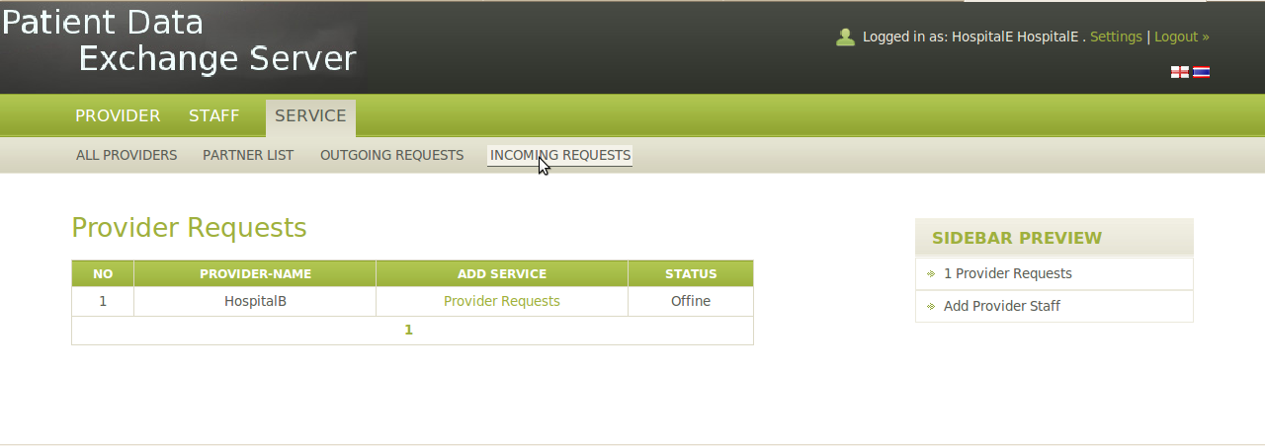

**Partner List**

Partner List will display the list of provider that you have been connected and can exchange a patient data between them.

